Online Book Store- HTML Live Lab 2

### Use Case:

It’s said, books are the best friends and they never leave you alone. Need to create a website that displays the different categories of the books and the most trending list of booksellers.

This website will allow the user to surf and look for different books, read the description and get the reviews before they decide to purchase .

The assignments in this lab are divided in 5 sections starting from easy to difficult level taking you through the process of creating a website for online book store.

NOTE:

Can change the color and styles or can choose your own images

### Lab Name: Assignment 1

### Content Mapping: HTML Images – I, HTML Block and Inline Elements

### Learning Pre-requisites:

- Tags: img [ width and height], background image, background size , float and animated gif

### Env Needed:

VSCode, Google Chrome

### Asset Needed: Images

### Difficulty: Easy

### Duration: 10 Minutes

Input:

- Use HTML tags h1, img, div to display the content and the images. Use float left to place the animated book image and place the text right beside it.

- Use background image , background size(100% and 100%) and height on a div to place the image in the background that will create the banner image

Output:

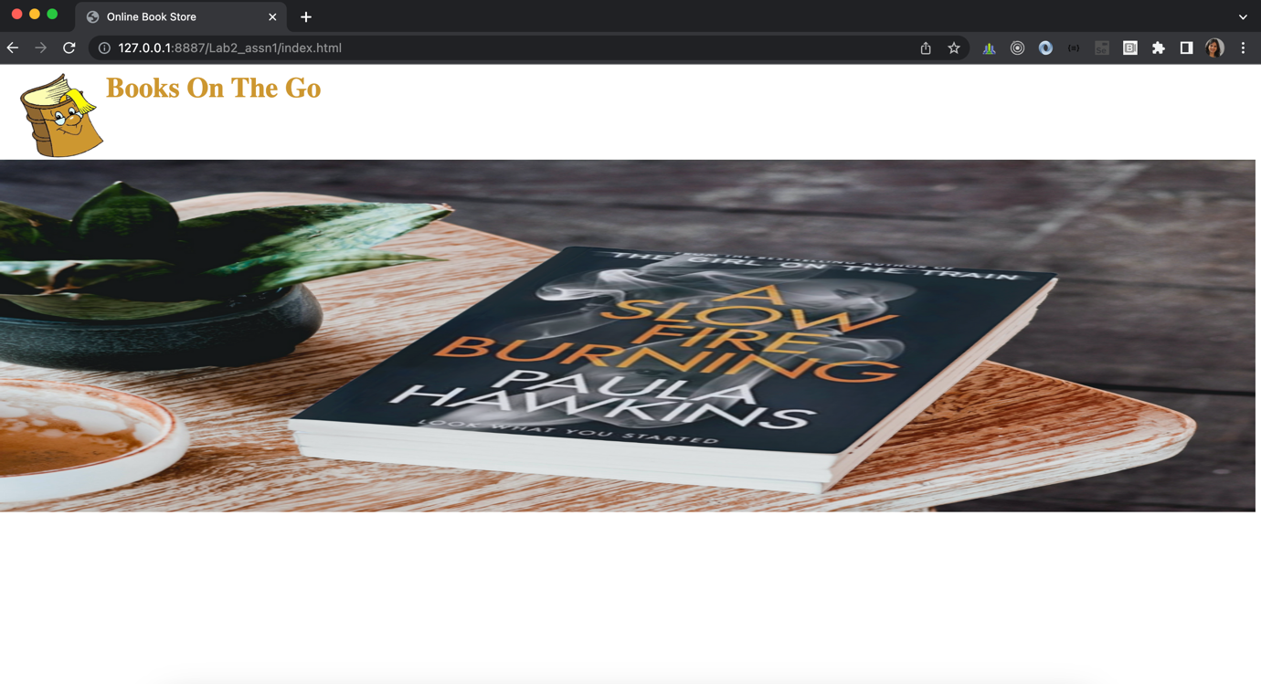

This image should be animated

### Lab Name: Assignment 2

### Content Mapping: HTML Images – I, HTML Block and Inline Elements, HTML Formatting

HTML Style, HTML Quotations, HTML Lists

### Learning Pre-requisites:

- Tags: img [ width and height], background image, background size , float and animated gif, quotes, fonts, styles, mark, lists

### Env Needed:

VSCode, Google Chrome

### Asset Needed: Images

### Difficulty: Easy

### Duration: 10 Minutes

Input:

- Add list above the banner with anchor links as list item. Clicking on every link should take to the heading of that link on the same page

- Below banner add the heading for quotes, Categories and Books, display as shown below

- Add quotes using blockquote, set font size and add the author who write that placed as text align right

Output –

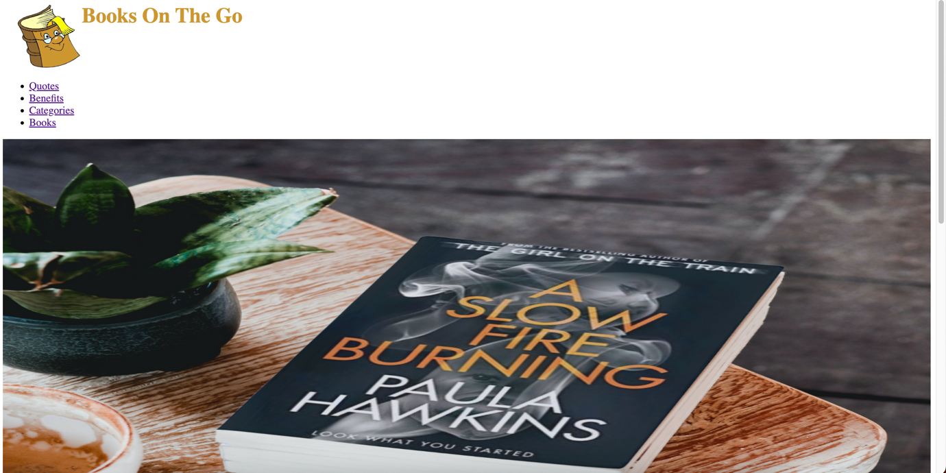

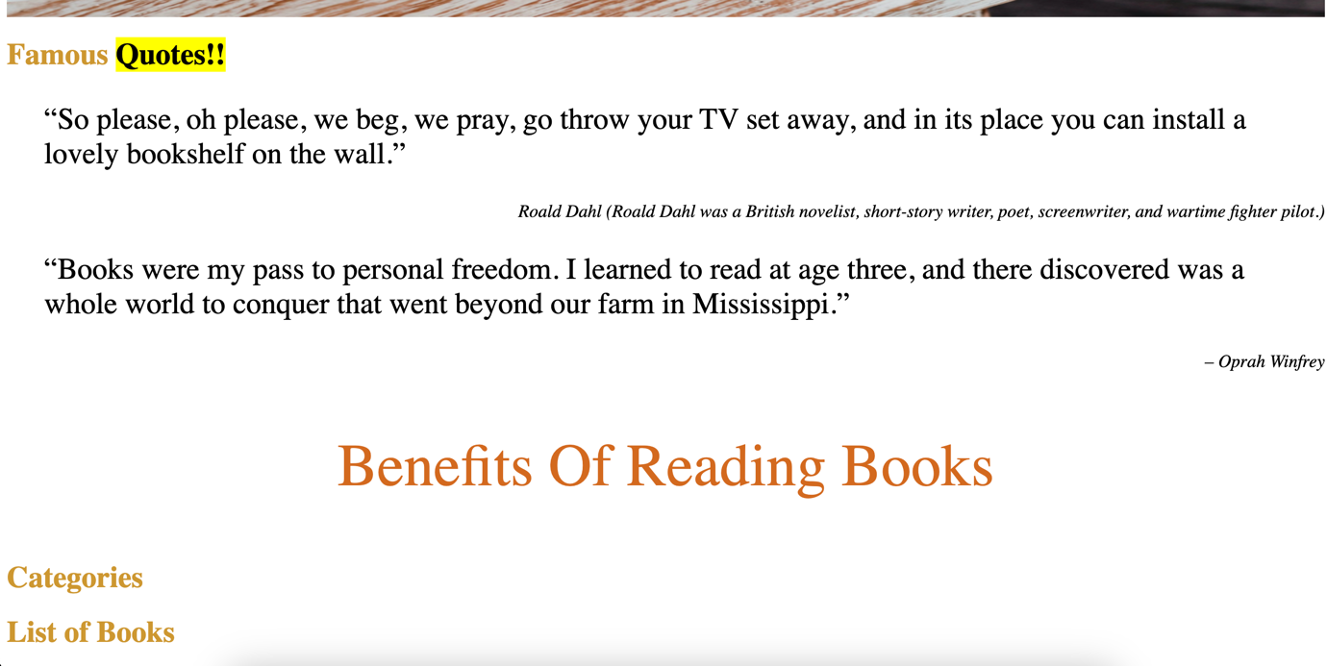

### Lab Name: Assignment 3

### Content Mapping: HTML Images – I, HTML Block and Inline Elements, HTML Formatting

HTML Style, HTML Quotations, HTML Lists, HTML Block and Inline Elements

HTML with CSS

### Learning Pre-requisites:

- Tags: img [ width and height], background image, background size , float and animated gif, quotes, fonts, styles, mark, lists, border, em, span, strike

### Env Needed:

VSCode, Google Chrome

### Asset Needed: Images

### Difficulty: Medium

### Duration: 20 Minutes

Input:

- Update the benefits as shown in the image. Use strike , border, list and paragraph within the list. Increase the font size of lists.

- Add list for categories as shown below and add links for fiction, biography and children. Do create 3 html pages for each category

- In every html page, do add the background image for the banner

Output –

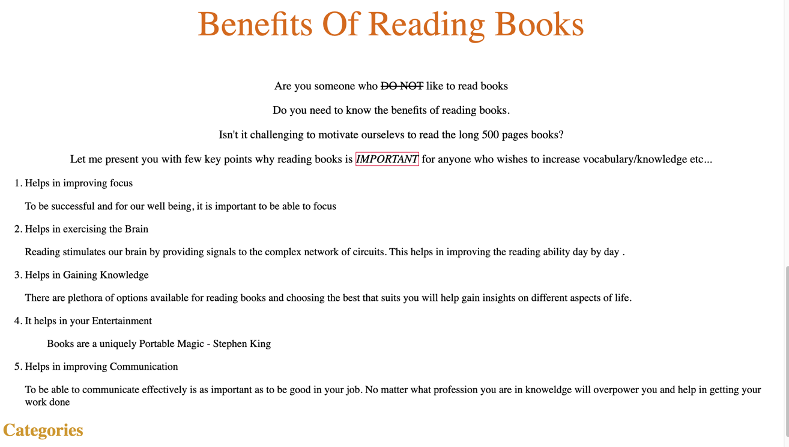

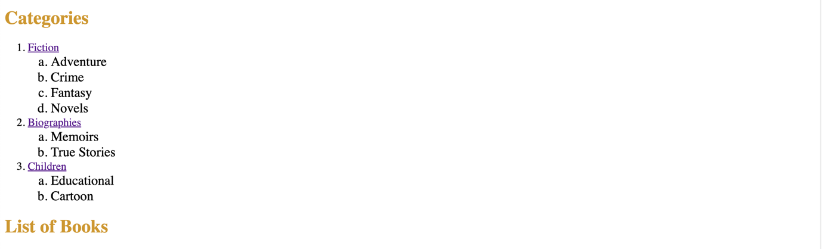

fiction.html



Biography.html



Children.html

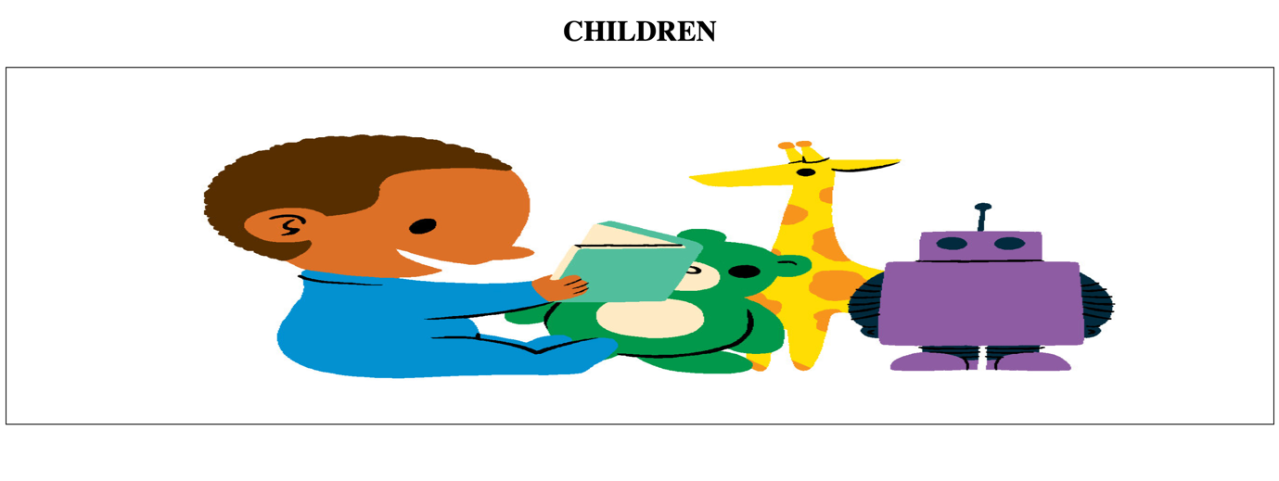

### Lab Name: Assignment 4

### Content Mapping: HTML Images – I, HTML Block and Inline Elements, HTML Formatting

HTML Style, HTML Quotations, HTML Lists, HTML Block and Inline Elements, HTML Tables

HTML with CSS

### Learning Pre-requisites:

- Tags: img [ width and height], background image, background size , float and animated gif, quotes, fonts, styles, mark, lists, border, em, span, strike, table

### Env Needed:

VSCode, Google Chrome

### Asset Needed: Images

### Difficulty: Medium

### Duration: 20 Minutes

Input:

- Add the list of books as shown below using table

Output –

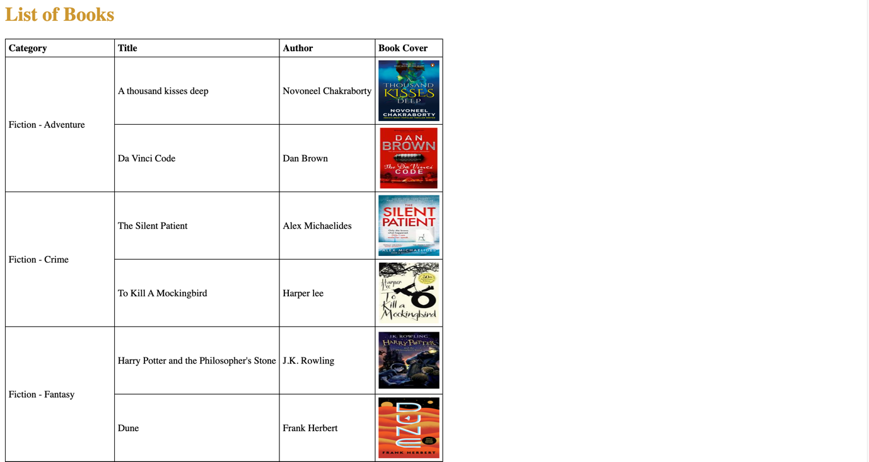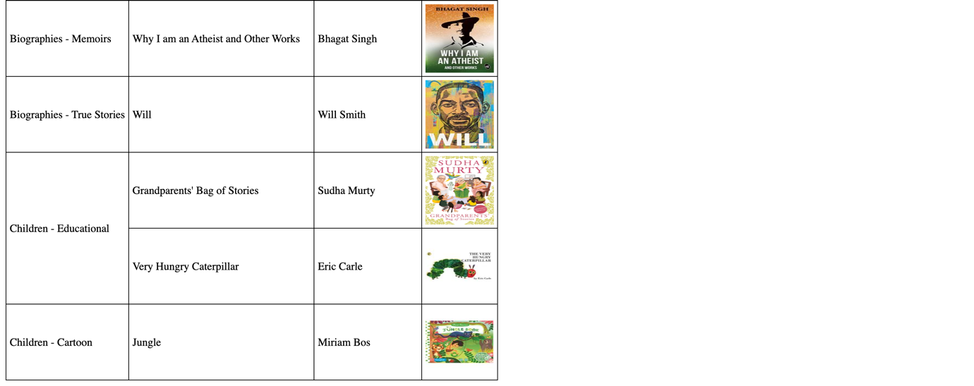

### Lab Name: Assignment 5

### Content Mapping: HTML Images – I, HTML Block and Inline Elements, HTML Formatting

HTML Style, HTML Quotations, HTML Lists, HTML Block and Inline Elements, HTML Tables

HTML with CSS

### Learning Pre-requisites:

- Tags: img [ width and height], background image, background size , float and animated gif, quotes, fonts, styles, mark, lists, border, em, span, strike, table

### Env Needed:

VSCode , Google Chrome

### Asset Needed: Images

### Difficulty: Difficult

### Duration: 30 Minutes

Input:

- Create fiction.html, biography.html and children.html as shown in the images below:

Output –

Fiction.html

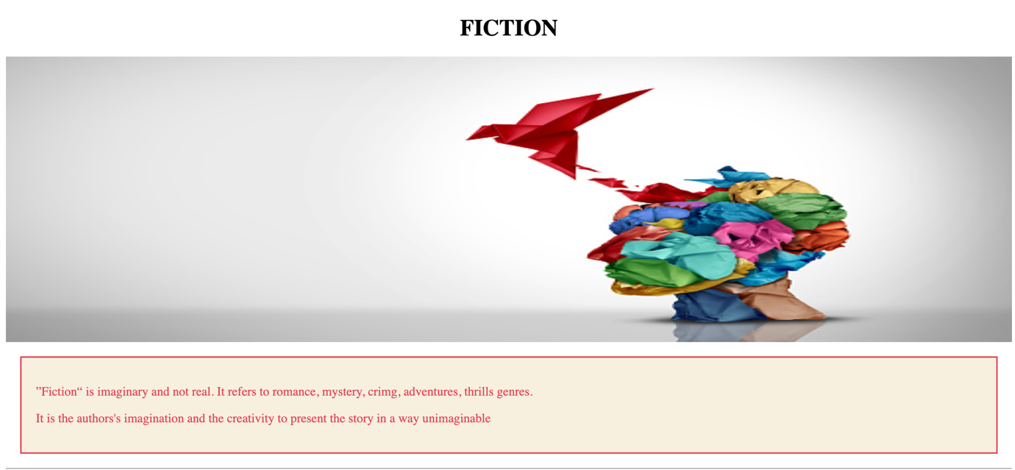

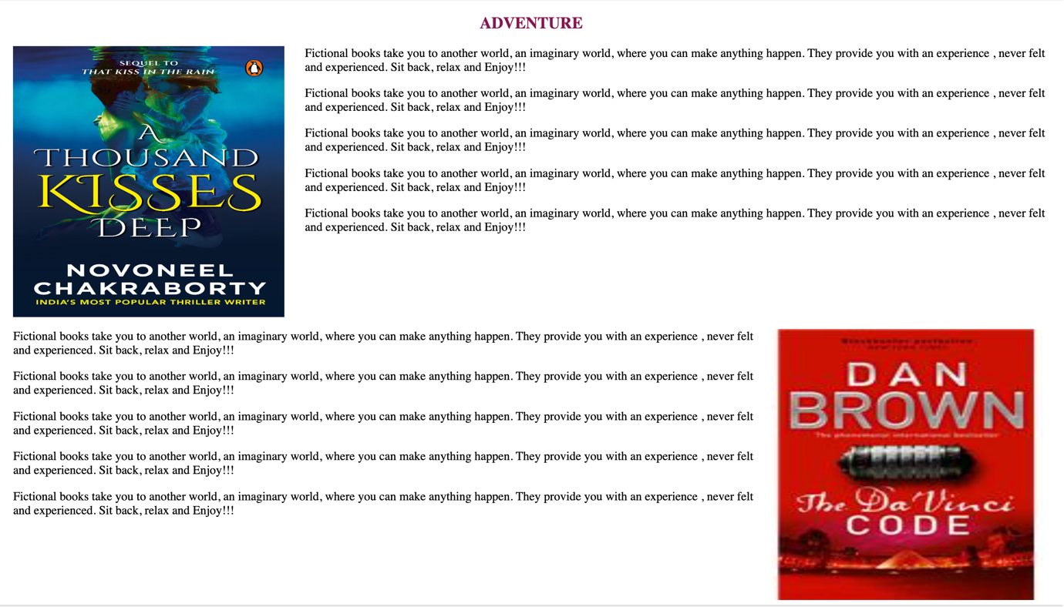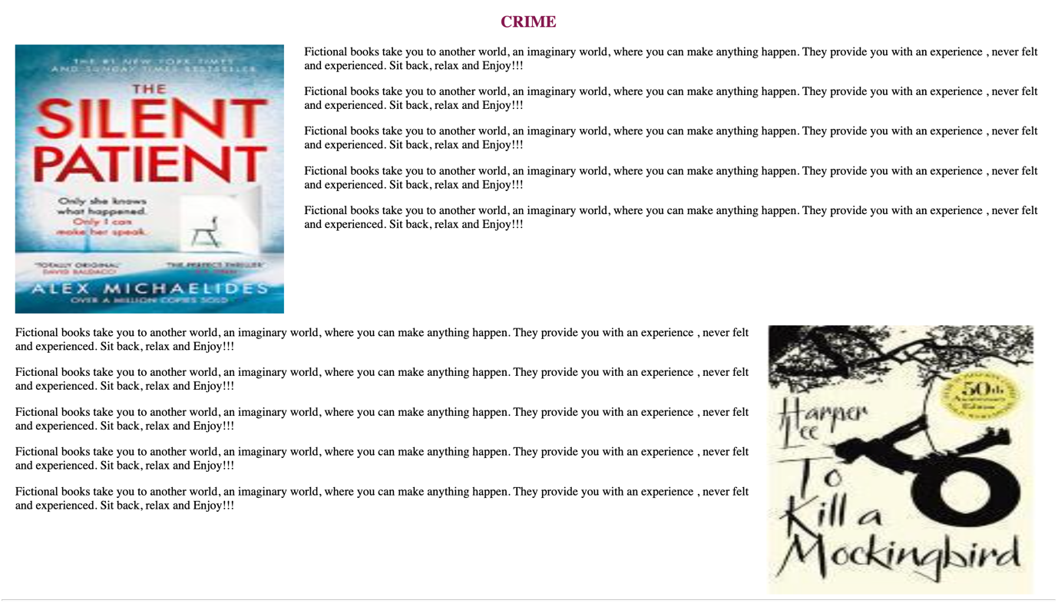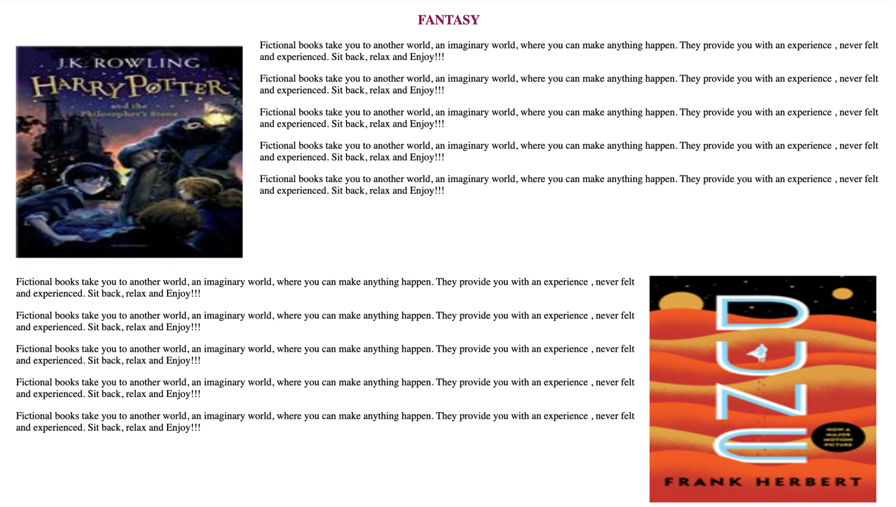

Biography.html

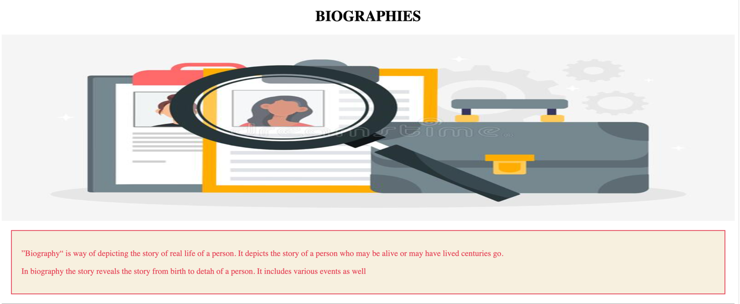

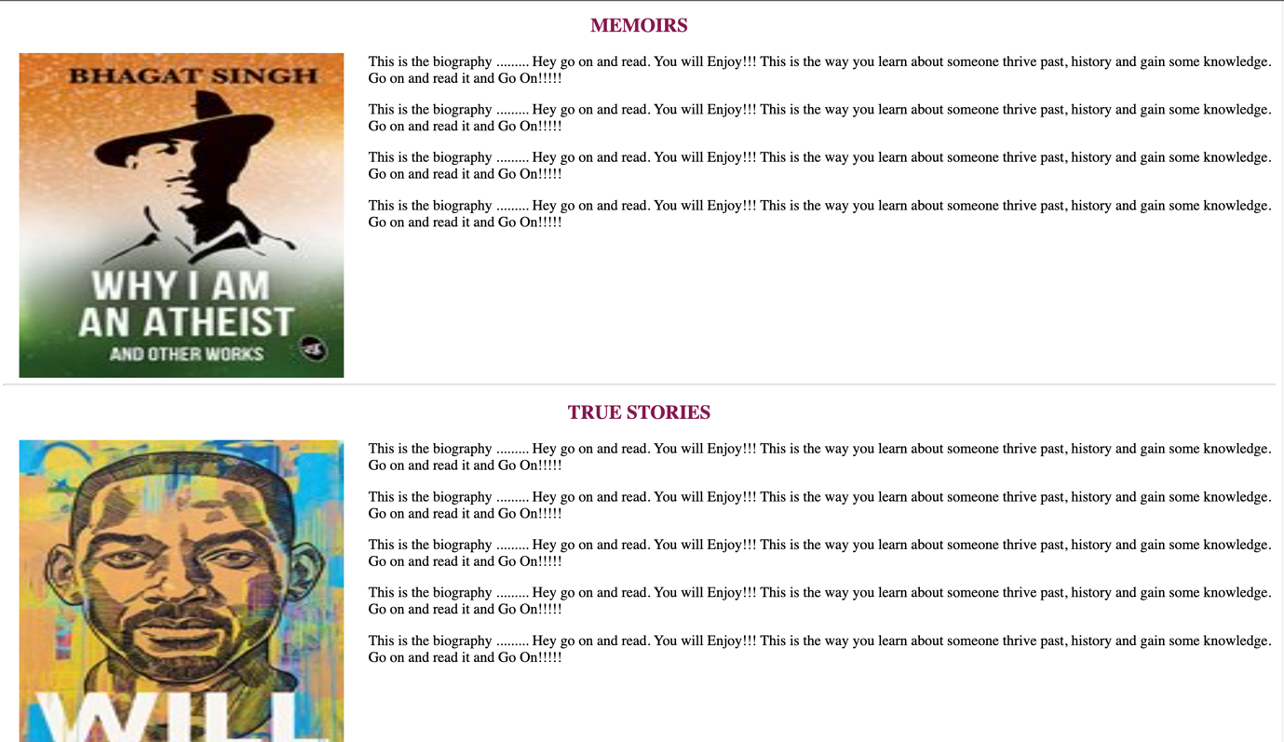

Children.html

